# My legal obligations app – what do I need to do

Current issues

1. How do I make it look prettyHow do I get all the pages in the right order - look at Jack’s notes for the routes.
2. passing the params number into the page after new entites – the show page
3. How do I enable a person to select from a pre-filled list of entities, when they are selecting tasks.

# Database side

## Create the following tables

1. Legal obs model
   1. Entity
   2. Name
   3. ACN
   4. Key contact
   5. Address
2. agreement:
   1. Agreement_name
   2. Agreement_date
3. clause
   1. clause text
   2. clause description – validate performative or protective
4. task:
   1. task description
   2. due date
   3. [*Assume for now that only one legal due date*]
5. User model:
   1. user
   2. name

## Create the relationships between the various tables

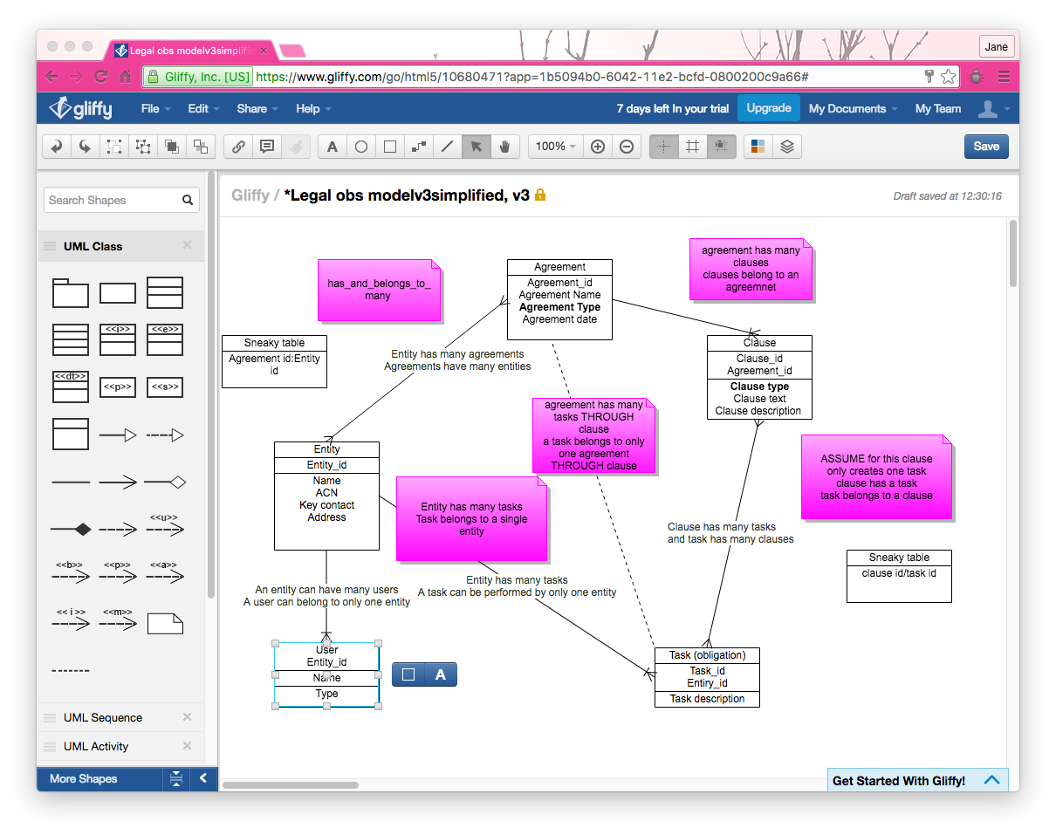

1. entity and agreement – has_and_belongs_to_many
   1. an entity can have many agreements
   2. an agreement can have many entities
2. agreement and clause -
   1. an agreement has many clauses
   2. a clause belongs to only one agreement
3. clause and task ASSUME FOR THIS IT’S a one to one relationship
   1. a clause creates a task
   2. a task belongs to aclause
4. an agreement and tasks
   1. an agreement creates tasks *through clauses*
   2. a task is created by an agreement through clauses
5. task and entity
   1. an entity has many tasks *through* agreements
   2. an agreement belongs to many entities through agreement
6. a user and entity
   1. a user can belong to only one entity
   2. an entity can have many users

# Create the crud

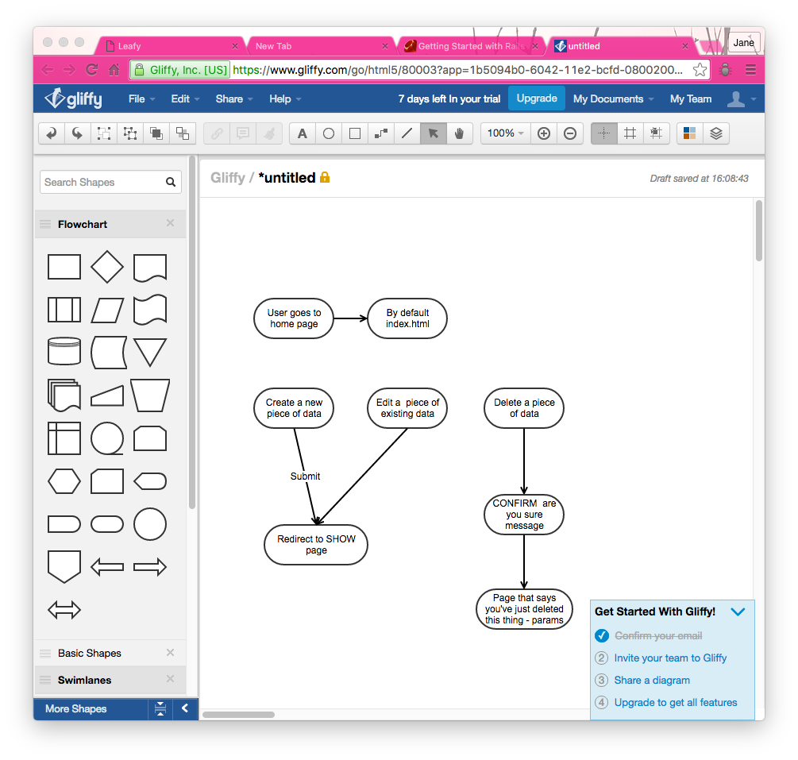

Goal

|  |  |  |
| --- | --- | --- |
| Create | Legal model | One form:  Add a new agreement – includes entity, clauses, tasks and dates |
|  | User model | One form  add a new user - needs to also pull in information about the entity the user is part of |
| UPDATE | Legal model | Update form for agreement |
|  |  | Update form for user – update password |
| READ | Legal model | Show me OVERVIEW   1. all the entities that I have legal obligations with   LOGIC – will need to recognize from the user_id which entity the user belongs to. Will need to DISPLAY the results based on that users entity ie  need to be able to chain from here via links to see the details of the source of the obligations   1. show me all of my pending obligations   see logic   1. show me all of the obligations that another entity has to me   Show me DETAIL of the source of the obligation  Obligation name, agreement date, other parites, clause |
|  | User model | Show me all users |
| Destroy | Legal model | Delete an agreement  logic – must automatically delete associated clauses, tasks and parties  Delete a task  must not delete the associated agreement unless there is only one |
|  | User model | Delete a user  Must not delete the associated entity, unless there is only one entity |

# Create the user password and log-in model

See the tunr app for this

# Add an API

Chronofy

# Load up to Heroku



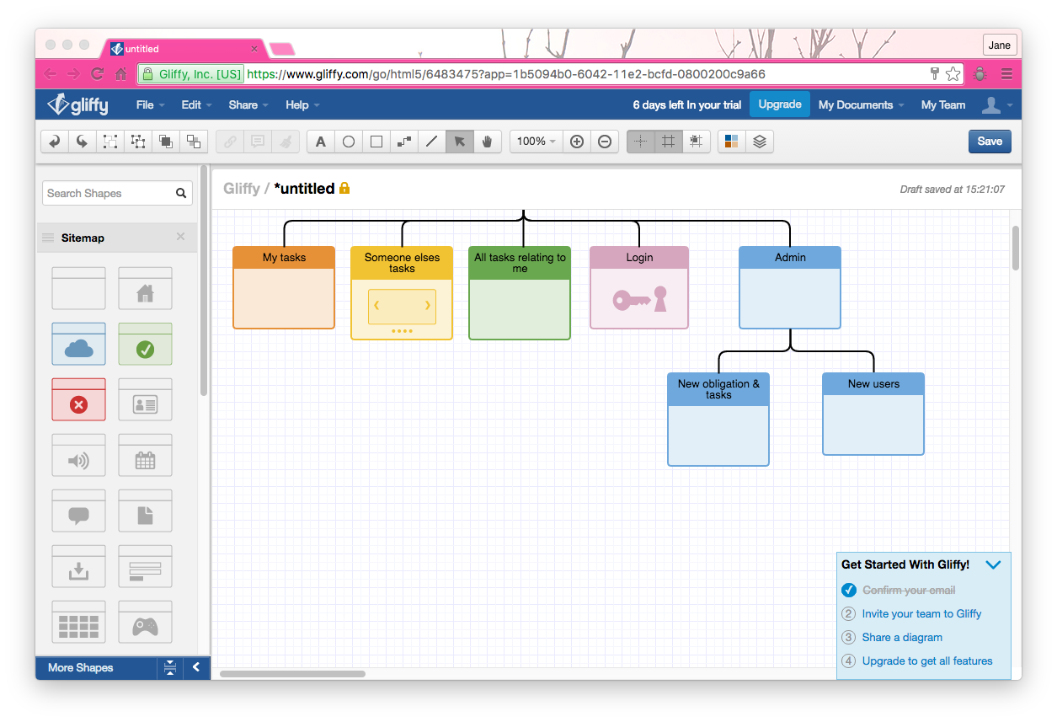

|  |  |  |  |
| --- | --- | --- | --- |
| Navigation pathway | What content to display | Current page in app | Works? |
| Enter the site | Entry page – login or register | Pages#home |  |
| Link from pages#home | Link to log-in from pages#home | pages#home | Yes |
|  | Login successfully | Pages#show | Yes, when go to /pages  No from the log-in page – which I can’t get to |
| Link from pages#home | Register |  |  |
|  |  |  |  |
|  |  |  |  |

Home page

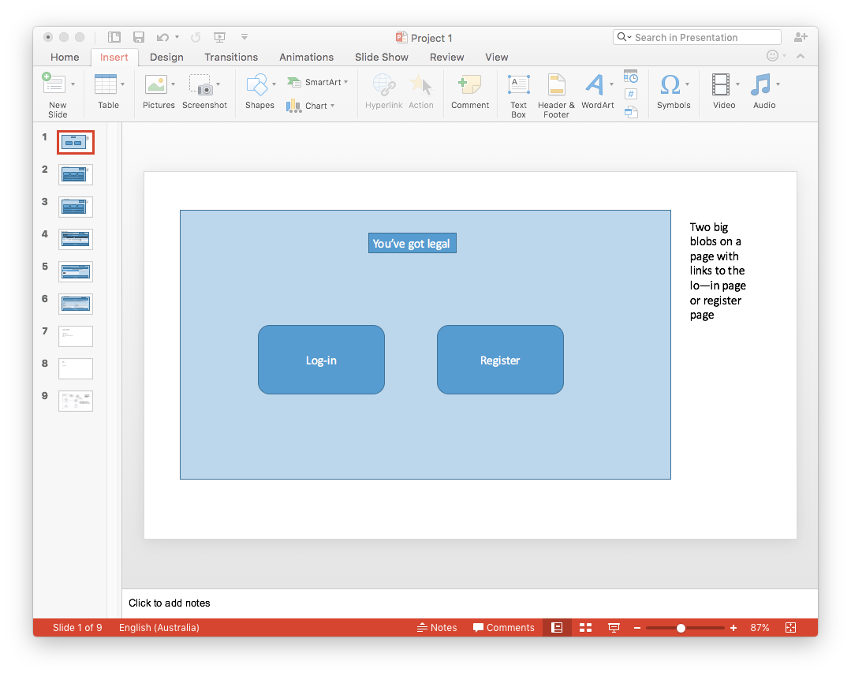

Next page – links also

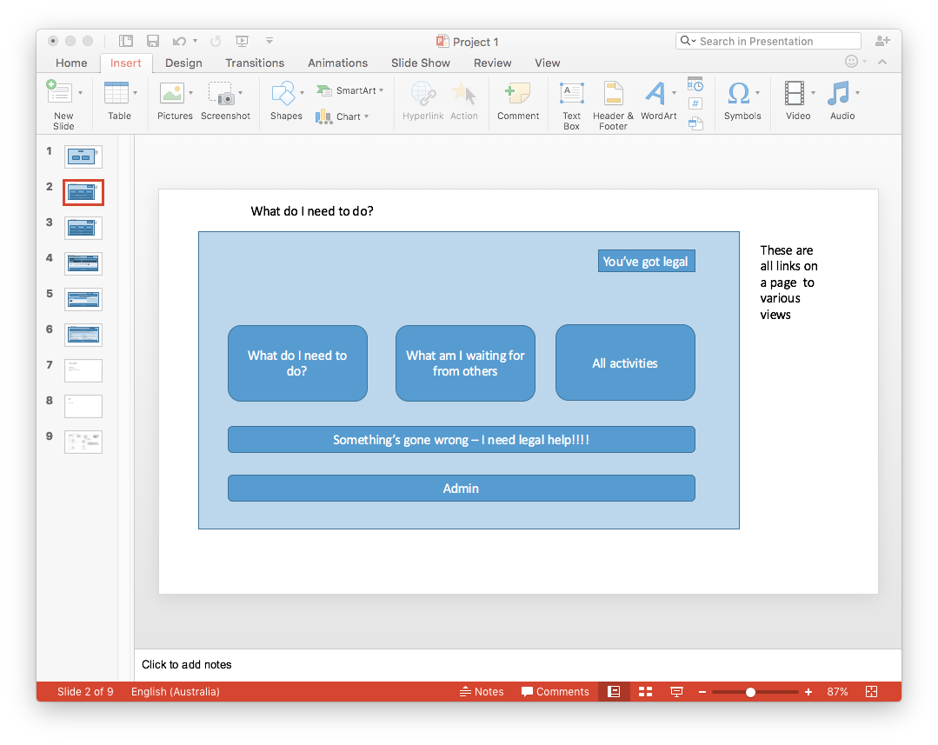

Page drawing from the DB

This is a view of the database. It needs to:

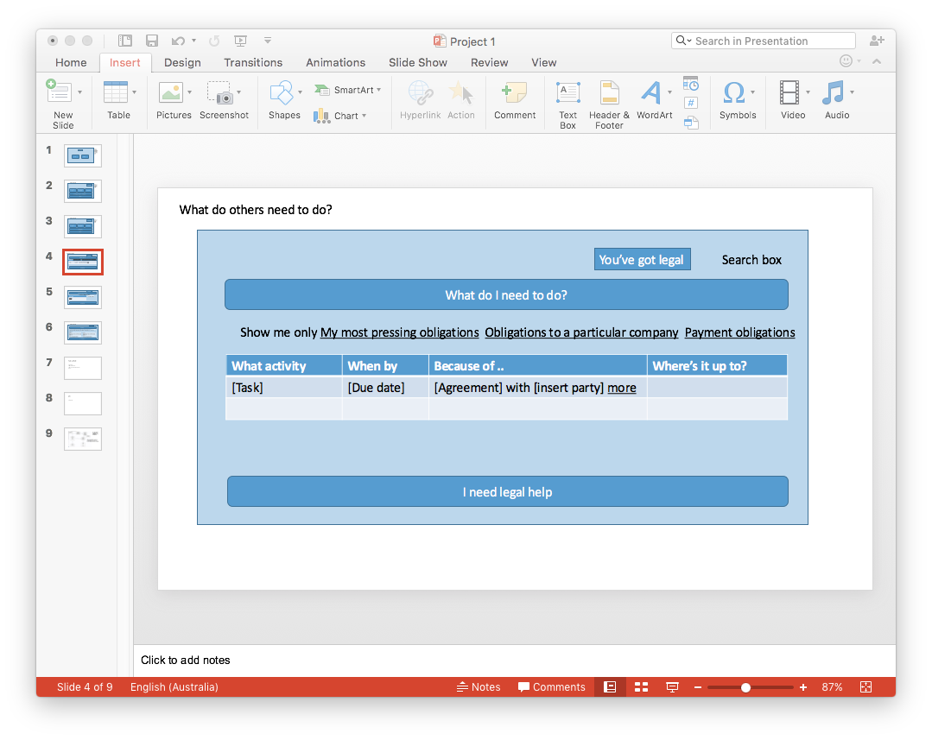

Jack says that this is an entities show page.

|  |  |  |
| --- | --- | --- |
| filter the DB data to show only those obligations that include the entity_id of the user | **obligation subset** = find all obligations where entity_id is the same as the entity_id in the user_id  this needs to filter all obligations = entity_id of the user [should I have a tag for this?] | **params needs to pass user_id into the search**  **from there need to find and show (loop through) all Obligations.first.ententity_id** |
| It then needs to show tasks to be performed by the entity_id of the user CHECK TASK AND ENTITY CONNECTION | **relevant tasks**  - within the obligation sub-set list all  tasks assigned to the entity_id that is the same as the entity_id of the user  FOR THE OTHER VIEW – show tasks where the entity_id doesn’t equal user_id’s entity’s_id  [schema - task has one entity – that’s ok  from the list need to then find all the tasks in the obligation that belongs to an entity that is not equal to the entity_id of the user] |  |
| the description of of the task | for those tasks – say the name of the obligation that the clause belongs to |  |
| the date of the task | for those tasks – say the date |  |
| the obligation that it came from | for those tasks – say the obligation it belongs to |  |
| the clause it came from | for those tasks – say the clause it belongs to |  |

# What am I waiting for from others?

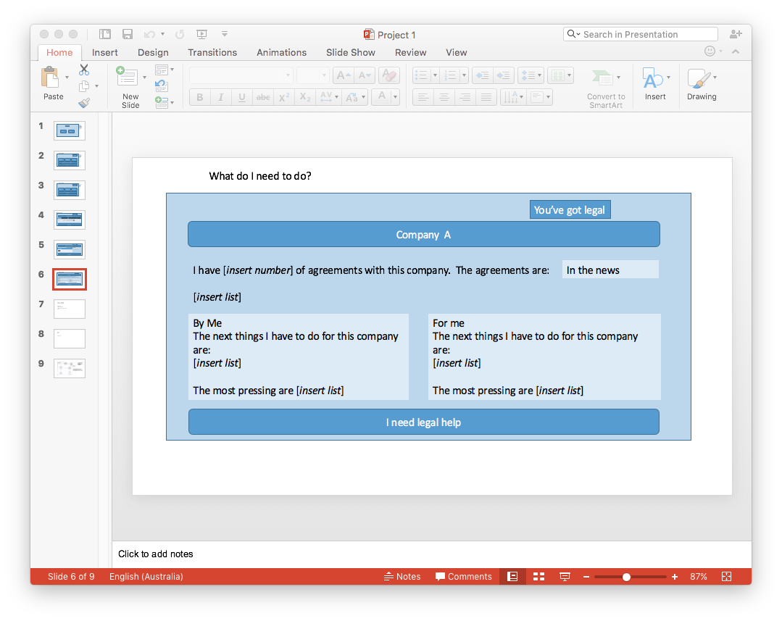

same selection of obligations = entity_id of the user_id

when displaying tasks, display the tasks that relate to that sub-set of obligations that belong to an entity whose id doesn’t equal the entity_id of the user.